PhishGuard
HACK-O-WEEK | WEEK 11-12
React Hooks and React Router

Section 1: Title
Hack-O-Week • Week 11-12 • React Hooks and React Router. This report connects the college assignment to the inspected PhishGuard source code.

Section 2: Objective
Identify hooks that solve current PhishGuard needs and distinguish those from routing or hook patterns not used by the application.

Section 3: Theory
Hooks in use. useRef stores a mutable value or DOM reference without making it render state. useMemo caches derived results while dependencies are unchanged. useCallback caches a function identity. useContext reads shared context. A custom hook packages reusable hook logic.
React Router. Routes map browser paths to components; nested routes share layouts; route parameters identify records; navigation changes location without a full page load.

Section 4: Implementation in PhishGuard
URLScanner uses useRef to focus the input and guard duplicate in-flight work. It uses useCallback for handleAnalyze, whose identity depends on onNewResult. ScanHistory uses useMemo for filtered records. App uses useEffect for cross-tab storage synchronization. The project has no React Router dependency, no useContext call, and no custom hooks; current views are one-page sections navigated by anchor links and scrolling. Educational examples below show route parameters, context, and a custom hook without claiming they exist.

Section 5: Code Explanation
useRef and useCallback
Source: frontend/src/components/URLScanner.jsx
Actual implementation. A DOM ref focuses an invalid input. A mutable ref guards duplicate requests without triggering a render. The corresponding code is in this week’s companion Code_Examples.md file.
useMemo derived list
Source: frontend/src/components/ScanHistory.jsx
Actual implementation. The filtered list is recomputed when history or query changes; memoization is useful if deriving this list becomes costly. The corresponding code is in this week’s companion Code_Examples.md file.
Custom hook and Context API
Source: Educational example (not in PhishGuard)
Educational example. A custom hook groups reusable state logic. useContext reads shared state provided by a context; both patterns are absent from the application. The corresponding code is in this week’s companion Code_Examples.md file.
Nested routes, parameters, and navigation
Source: Educational example (not in PhishGuard)
Educational example requiring React Router, which is not in package.json. The nested routes share Layout; :scanId is a route parameter and navigate changes location. The corresponding code is in this week’s companion Code_Examples.md file.

Section 6: Working Flow
- The input ref is attached to the URL field and focuses it after validation feedback.
- handleAnalyze guards duplicate requests and calls the API.
- The scanner updates loading/result state; ScanHistory derives a filtered list from history and query.
- To add page routes, an educational Router setup would map dashboard, history, and /scan/:scanId to separate views.

Section 7: Learning Outcome
Hooks in the current app support DOM access, request coordination, stable callbacks, effects, and derived history. Router, context, and reusable custom hooks are assignment concepts demonstrated separately as examples.

Section 8: Code Implementation Screenshots
Captured from the project source file open in Visual Studio Code. Captions identify the displayed file. Code examples are in the companion Code_Examples.md file, not in this Word report. Educational examples there are labeled and are not application code.
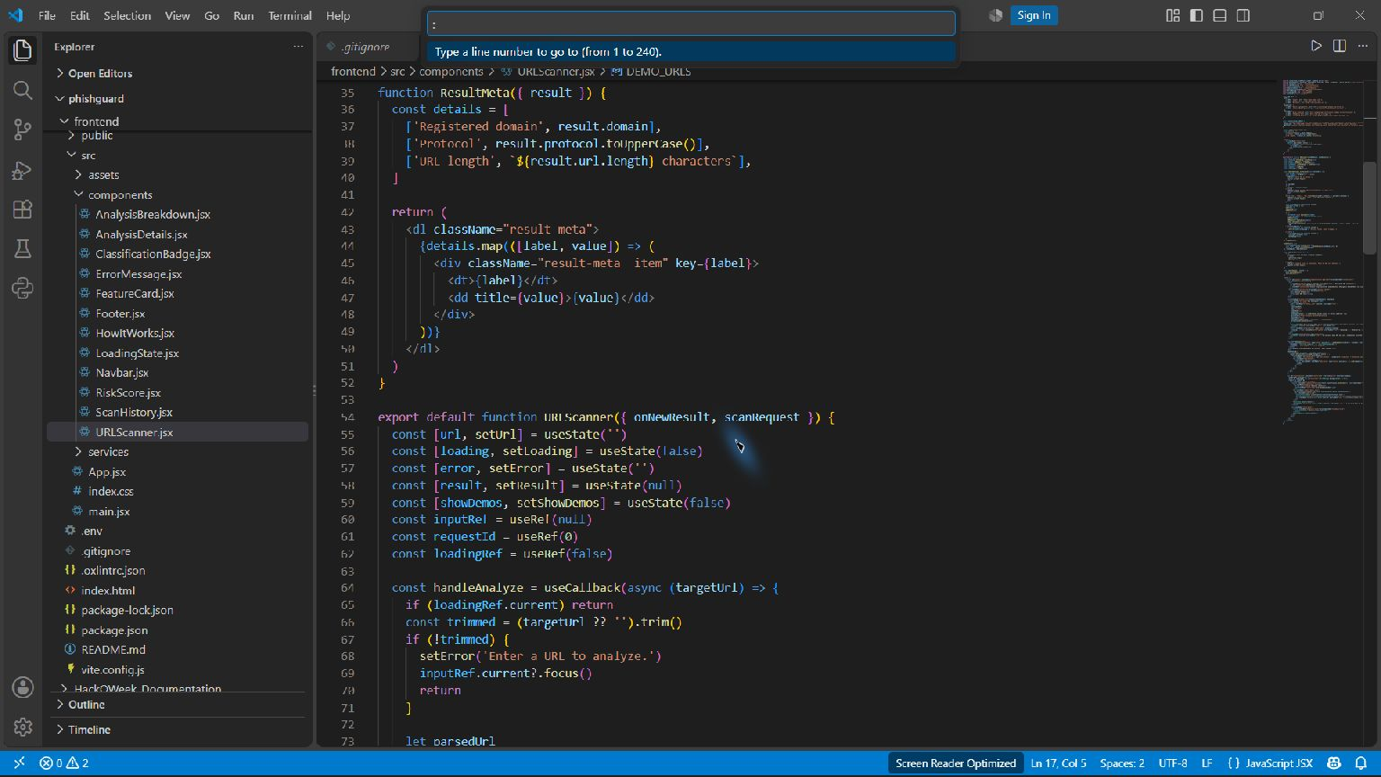
Actual useRef and useCallback in URLScanner — frontend/src/components/URLScanner.jsx
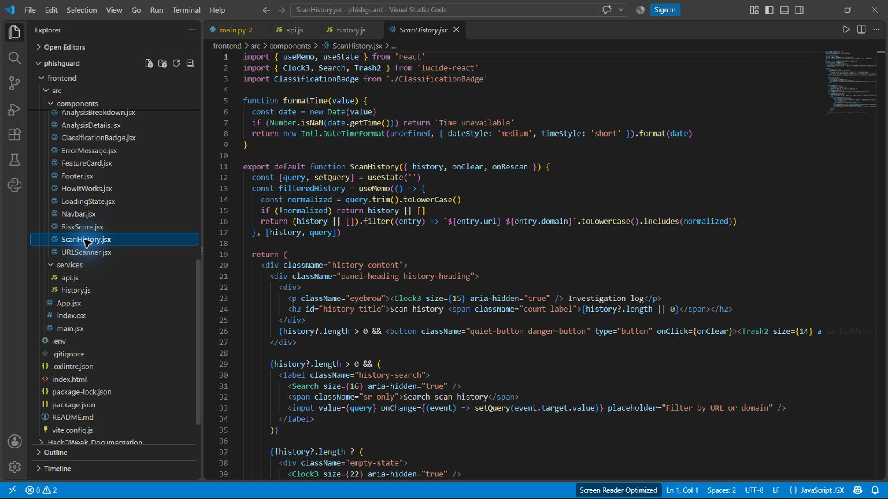
Actual useMemo for filtered history — frontend/src/components/ScanHistory.jsx

